Lear, Michelle (Stud. DKE)

i6240491

**Image and video processing**

**Project 2**

Table of Contents

1. Image Degradation 2

1.1. Degrading the Image And Adding Noise 2

1.2. Removing Noise 2

1.2.1. Remove Motion Blur – Direct Inverse Filtering 2

1.2.2. Remove Motion and Additive Noise 3

1.2.3. Minimum Mean Squared Error – Motion Blur 4

1.2.4. Minimum Mean Squared Error – Motion Blur and Gaussian Noise 4

2. Image DCT – Hidden Message 4

2.1. Watermark Insertion 4

2.2. Watermark Detection 8

3. Morphology 8

3.1. Counting 8

3.1.1. Counting Oranges On A Clear Surface 8

3.1.2. Counting Oranges on a Tree 9

3.2. Granulometry 9

4. PCA – Recognition 9

4.1. Eigenfaces 9

4.2. Reconstruction 11

4.3. Reconstruction With Different Eigenface 12

# Image Degradation

## Degrading the Image And Adding Noise

To degrade an image, it is necessary to have a degradation function. In this case, $H\left(u,v\right)=\frac{\sin{αu+βv}}{αu+βv}∙exp⁡(-jπ\left(αu+βv\right))$ where $u, v$ are variables from a mesh grid made from the width and height of the image, $α, β$ are constants that are chosen – these constants can be any number greater than 0, the higher the greater the motion blur – and $-j$ is an imaginary number. The values chosen were $α=16$ and $β=12$. These values were found to apply a visible motion blur without degrading the image too much.

To actually apply the degradation function, the image has to undergo certain changes first; it has to be of a numerical type so the function can be applied to its pixels. Then, we can apply the degradation function to get some value $H$. After getting $H$, we need to find the Fourier Transform of the image to multiply with $H$. $F*H$ applies the degradation to the image and gives us an image with motion blur.

The next step was to apply gaussian noise to the new blurred image. This was done using the inbuilt function, “np.random.normal()” with $μ=1.1$ and $σ=0.8$. These values for mu and sigma were found to apply the (objectively) perfect amount of noise to the image; the noise is visible but not overpowering.

Figure : Original, Motion and Gaussian Blur

Figure 1 above shows the original, motion and gaussian blurred images. The motion blur is visible in the middle plot of the figure which indicates that the steps mentioned in the above paragraphs were successful. Furthermore, after adding the gaussian blur, the image become lighter but the motion blur is still visible.

## Removing Noise

### Remove Motion Blur – Direct Inverse Filtering

To remove the motion blur, a direct inverse filtering method was used. This is a type of high pass filter so it is sensitive to noise but for this task there is no noise so that should not be a problem. The formula, $\hat{F}(u,v)=\frac{G(u,v)}{H(u,v)}$ where $G$ is the blurry image and $H$ is the degradation function, gives us a deblurred image which hopefully resembles the original image. In this A bird flying over a tree
case, the following image was obtained after applying the formula to the blurred image.

Figure : Direct Inverse Filtering for Motion Blur

It appears to still be blurred after the transformation which is strange because the code should work. I am not sure why this is but I have attached the image to show what I tried.

### Remove Motion and Additive Noise

When there is additive noise in the image, the formula for inverse filtering becomes $\hat{F}\left(u,v\right)=\frac{G\left(u,v\right)}{H\left(u,v\right)}-\frac{N\left(u,v\right)}{H\left(u,v\right)}$ where $N\left(u,v\right)$ is the added noise. This extra variable in the formula becomes a problem when $H(u,v)$ is zero because $\frac{N\left(u,v\right)}{H\left(u,v\right)}$ becomes very large which causes an amplification of noise even if it was not there initially. This can be seen in the figure below. The expected deblurred image seen in Figure 3 is actually extremely noisy. This is the effect of the added variable in the formula. The Wiener filter is more suited for deblurring images with additive noise.

Figure : Denoised Motion and Gaussian

It is quite difficult to see the contents of the image as it is very dark but if you are in a dark environment, you can see that the bird in the image. The image appears to be black and this is because of the amplification of noise described above.

### Minimum Mean Squared Error – Motion Blur

The formula for the minimum mean squared error is the Wiener filter’s transfer function $H_{w}\left(u, v\right)=\frac{1}{H\left(u,v\right)}*\frac{{|H\left(u,v\right)|}^{2}}{{\left|H\left(u,v\right)\right|}^{2}+\frac{S_{n}\left(u,v\right)}{S_{f}\left(u,v\right)}}$, where $H(u,v)$ is the degradation function, $S_{n}(u,v)$ is the noise power spectrum and $S_{f}(u,v)$ is the original images power spectrum. These values are easily calculated using Pythons numpy library.

Figure 4 shows the motion blurred image (seen in Figure 1) after Wiener filtering. The image has significant decrease of motion blur and seems to have unnoticeable difference from the original image.

Figure : Wiener Filtering of Motion Blur And Gaussian Noise

### Minimum Mean Squared Error – Motion Blur and Gaussian Noise

The same transfer function $H_{w}\left(u,v\right)$ is used for the image with motion blur and gaussian noise. The only difference is that we include a constant K which approximated the ratio of the noise power spectrum and the original power spectrum. K is calculated by finding the average of their true ratios using the formula for signal-to-noise ratio $SNR= \frac{\sum_{x=0}^{M-1}{\sum_{y=0}^{N-1}{\hat{f}{\left(x,y\right)}^{2}}}}{\sum_{x=0}^{M-1}{\sum_{y=0}^{N-1}{{\left[f\left(x,y\right)- \hat{f}\left(x,y\right)\right]}^{2}}}}$, where $\hat{f}$ is the original image and $f$ is the noise image. In the end, the formula for the transfer function is $H_{w}\left(u, v\right)=\frac{1}{H\left(u,v\right)}*\frac{{|H\left(u,v\right)|}^{2}}{{\left|H\left(u,v\right)\right|}^{2}+SNR*\frac{S_{n}\left(u,v\right)}{S_{f}\left(u,v\right)}}$. This resulted in the following image.

Figure 5is quiet noisy, more so than before the filtering. I am not sure why this is the outcome of the image as I expected clearer image as in Section 1.2.3. Although, the output is not the best, it is better than with the direct inverse filtering which is expected.

Figure : Wiener filtering of Motion and Gaussian Blur

# Image DCT – Hidden Message

## Watermark Insertion

To create an invisible watermark in an image, the following steps were taken: firstly, compute a block wise 2D Discrete Cosine Transform (DCT) on a grayscale image. Figure 5 shows the DCT of the entire image on the left and on the right, a zoomed in portion of the DCT.

Figure : DCT

After computing the DCT, I had to choose K coefficients with the largest magnitude to keep their frequencies and the rest would be changed to 0. This was done via thresholding. A series of threshold values were tested and ultimately, a threshold of 0.01 was found to result in an inverse DCT that looked the same as the original image (as seen in Figure 6).

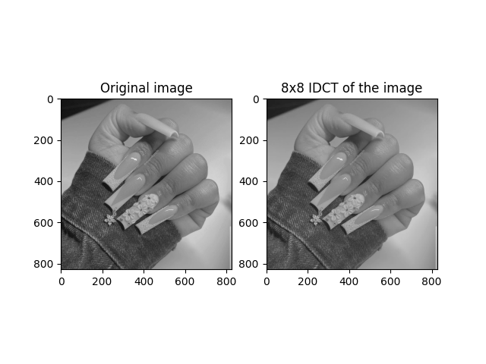For arguments sake, Figure 9, Figure 7, and Figure 8 show the IDCT for thresholds 0.02, 0.1 and 0.5 respectively.

Figure : Original and IDCT with threshold = 0.01

Figure : IDCT threshold = 0.1

Figure : IDCT threshold = 0.02

Figure : IDCT threshold = 0.5

At initial glance Figure 8 appears to be the same as the original but upon further inspection, one can see that the colours are slightly lighter than the original. Figure 7 is slightly blurry and so a threshold of 0.1 was found to not be appropriate and finally Figure 9 is extremely blurry and has a higher contrast than the original.

Next, I created a pseudo-randomly generated set of numbers with a gaussian distribution with $μ=0$ and $σ=5$. This set of random numbers was used as a watermark for the image. The watermark was embedded into the image using the following equation $c_{i}^{'}=c_{i}*(1+ αw_{i})$ where $α$ is a measure of intensity for the watermark, $c_{i}$ is the original DCT coefficient and $w_{i}$ are the randomly generated set of numbers. The next step was to decide on a value for $α$. Through trial and error, the final value used was $α=0.02$; this is because for values greater than 0.02, the watermark was visible. Figure 13 and Figure 14 show the watermark and the image with the watermark embedded. As seen, the watermark is invisible after being embedded which shows that the value of alpha is appropriate.

To demonstrate what other values of alpha produce, below show figures (Figure 10, Figure 11 and Figure 12) with alpha values 0.05, 0.4 and 1 respectively. For Figure 10, the watermark is not very obvious but when analysing thoroughly, a grid can be seen over the image. In Figure 11, the watermark is fairly obvious as it creates a mesh-like coverage on the image and also causes a bit of blur and finally, Figure 12 most obviously shows the watermark as the image is darker than the original and the grid can be seen very easily.

Figure : Alpha = 0.05

Figure : Alpha = 0.4

Figure : Alpha = 1

Figure : Watermark

Figure : Image with watermark

To have a better overview of the processes applied above, a difference image was calculated. A difference image determines the changes between two images by calculating the difference between each pixel in the images and generating an image based on the result (Wikipedia, 2016).

Figure : Comparison

It is quite hard to see, but the third image in Figure 15, a vague outline of the hand seen in the original image and watermarked image can be seen. This shows that there is a very small difference between the two images and further illustrates that the alpha value for the watermarking is appropriate for an invisible watermark.

Figure : Image Histograms

Figure 16 shows the histogram for the original image, the image with a watermark and the difference image (left to right). The watermarked image has a more dense plot than the original image. This makes sense because the watermarked image has more data than the original image even though the watermark is not visible. The difference image histogram shows that the range of difference is low therefore the inverse DCT transformation was successful as the goal is to have an image that is as similar to the original as possible.

The watermark is inserted on the non-DC coefficients for this exact reason, if the watermark is inserted where there are DC-coefficients, it will create noise and the image will appear different because it will overfit the coefficients.

## Watermark Detection

# Morphology

## Counting

### Counting Oranges On A Clear Surface

To count the number of similar objects in an image, I first converted the images to black and white images. This helped with having a clear indication of the objects. Next, dilate the image further to remove possible distortions from the image (See Figure 17). Then, find the contours in the image to locate the edges of the objects and use that as a count for the image.

Figure : Dilated Oranges

After applying all these steps to the original image, the code outputted that there were 24 oranges in the image. This is correct which shows that the code is functional.

### Counting Oranges on a Tree

Counting the number of oranges, or any fruit for that matter, on a tree can be difficult because there is, what we can consider as, noise in the image. Meaning, in the image, we want to focus on the oranges, but there are leaves and other objects in the image that make it difficult to specify what to count. A way to get around this is by using morphology techniques and a range of colours that we specify.

In this case, we are looking for orange objects in the image, therefore we have a range of [1,170,100] to [18,255,255]. This range

## Granulometry

# PCA – Recognition

## Eigenfaces

An eigenface is an image of a person’s face that can be added to the mean of their face to create a new facial image (Mallick, 2018). This can be calculated by getting the average of a set of images of one person’s face, subtracting this from each image in the set and then using this result to calculate the covariance matrix of the face. From the covariance matrix, the eigenvalues and eigenvectors can be found which finally give us the eigenfaces.

Figure : Eigenfaces for Kid

Figure 18 shows the eigenfaces for the kid image. Each of the images in the figure have different focuses but one common visible feature are the glasses.

Figure 19 shows the eigenfaces for the old man. These eigenfaces seem to have more data on the face shape than the kid image. This may be because the original image of the man was more centred than the kid image and thus the eigenvalues were higher for the old man images.

Figure : Eigenfaces for Old Man

Finally, Figure 20 shows the eigenfaces for the woman. These see to be the noisiest and the most merged. This may be because the background of the original image had similar colours to that of the woman’s skin. A lot of features are mixed up between the eigenfaces, for example, the eigenface for the image where the woman has long hair, the main feature is a beard (which is not seen in the image).

Figure : Eigenfaces for the Woman

## Reconstruction

Reconstruction of a facial image is done by adding one or multiple eigenfaces to the mean of an image. When this is done with the three facial images given, the following are the results.

Figure : Reconstruction of Kid's face

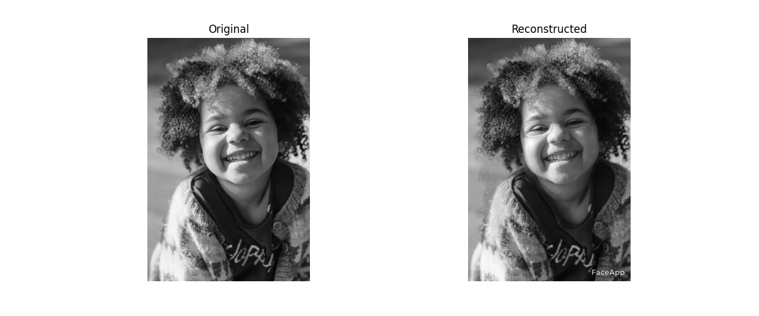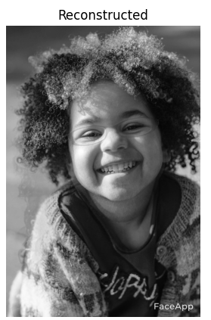

Figure 21 shows (from left to right) the original, reconstruction with 1 eigenface and reconstruction with 6 eigenfaces of the kids face. As we can see, the two reconstructions do not vary a lot but the original does not have a lot of the features seen in the reconstruction. This is because the reconstruction is done using the mean of the images, therefore it has data from other images that the original does not have. This is not a great example as the mean of the kid’s image is filled with data which creates a bias for the reconstruction.

Next, the reconstruction of the old man’s face can be seen in Figure 22. Like the kid’s reconstruction, very little difference can be seen between the two reconstructions (1 eigenface – left, and 6 eigenfaces – right). But a difference that can be seen here is that not all of the eigenfaces features can be seen in the reconstructions. This suggests that the eigenfaces used to reconstruct the facial images have a lower eigenvalue than the kid’s images as there is less data present in the images.

Figure : Reconstruction of the woman's face

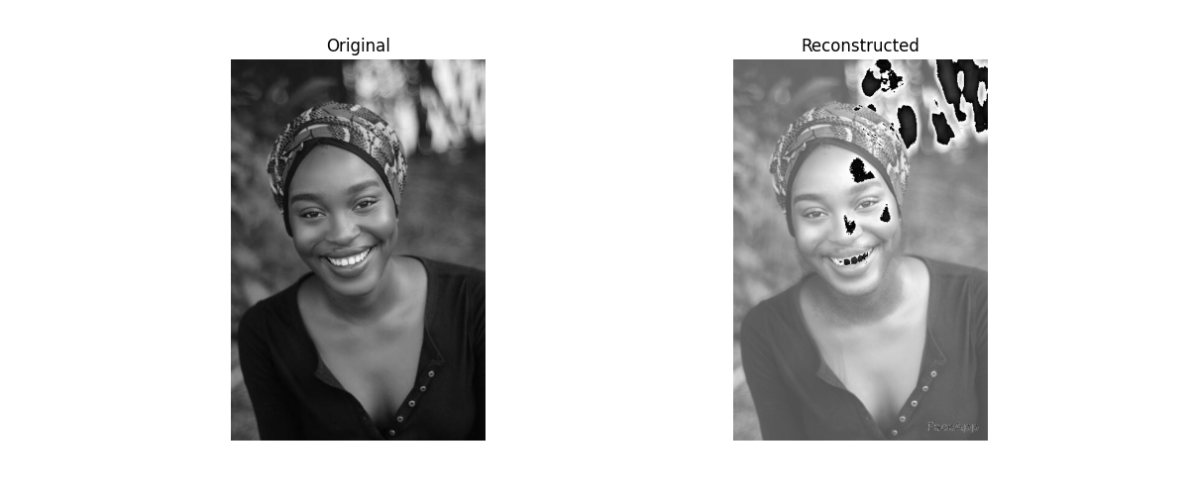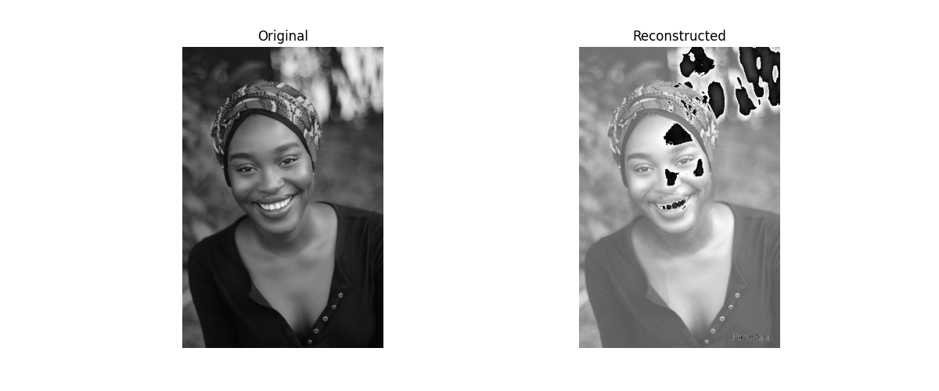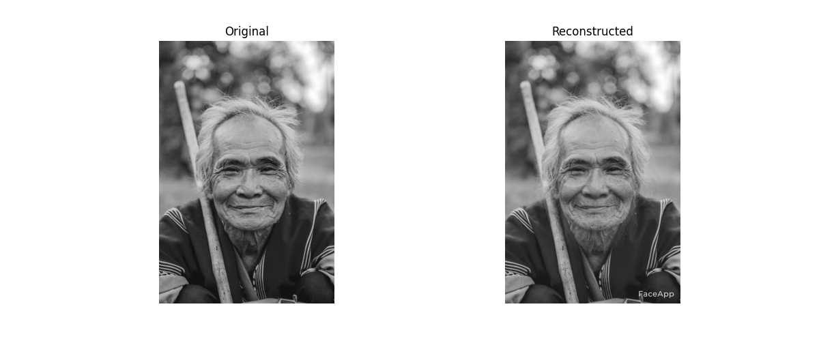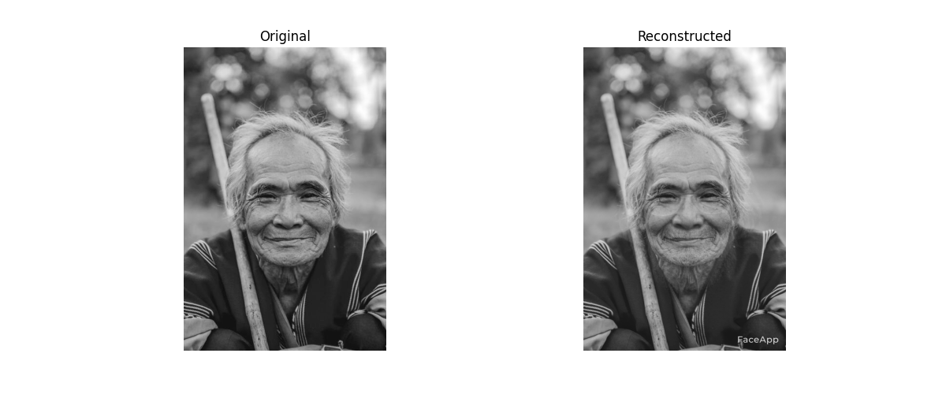

Figure : Reconstruction of the old man's face

Lastly, Figure 23 is the reconstructions of the woman’s facial images. These reconstructions were the most peculiar as the same program was used for all three sets of images but only this one came out with noise. The reconstructions show black marks on parts of the images that are not present in the original image nor in the eigenfaces. I do not know why this happens. On the reconstruction with 6 eigenfaces – the image on the far right – there is more of this black noise visible. This may be because all of the eigenfaces combined with the mean of the image amplify this.

## Reconstruction With Different Eigenface

For each eigenvector of a facial image, there is a corresponding eigenvalue. This eigenvalue tells us how much data is stored in the eigenvector so the eigenvector with the highest eigenvalue is the principal component where the most data lies. Taking this into account, when attempting to reconstruct a facial image with a different set of eigenfaces the eigenface with the highest eigenvalue will be used to reconstruct with a different face.